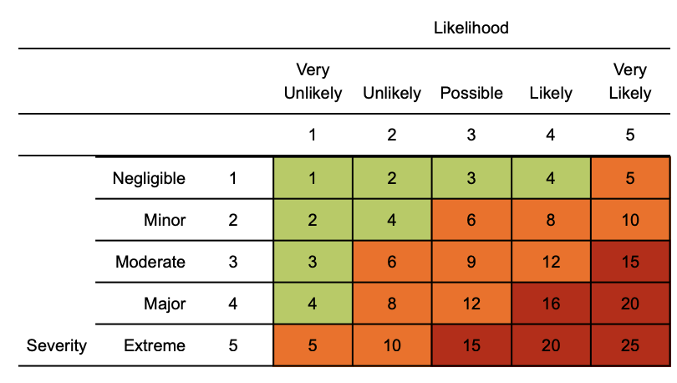
Risk matrix used in risk assessment below
RR = residual risk

Use guidance from Public Health England (PHE), Department of Health & Social Care (DHSC), Health & Safety Executive (HSE) and NHS to ensure the risk assessment is following the latest advice.

Coronavirus (COVID-19) inside premises risk assessment
Contents
Travel
Access & Egress
Welfare
DSE
Mental health / stress
Statutory documentation including Legionella

Assessment date: 1st June 2020
Review date: 1st July 2020
Version: 1.0

Hazard | Risk | Control measures | RR | Persons at risk
Travelling to work - risk of COVID infection from others | 4  x  3  =  12 | - Staff to only travel to work where work cannot be performed at home  - Personal vehicle, bike or walking to be conducted where possible to complete your commute to and from work  - Aim to minimize the frequency and amount of time using public transport  - If using public transport, face covering is recommended  - Look to travel outside rush hour periods where possible and to review starting / finishing times for staff to limit | 4  x  1  =  4 | Individual members/staff
Suspected case whilst working within the premises | 4  x  4  =  16 | If a person develops a high temperature or a new, persistent cough they should:  - Return home immediately  - Avoid touching anything  - Self isolate for a period of 7 days | 4  x  1  =  4 | Individual members/staff
Access / egress to the premises | 4  x  4  =  16 | - Stop all non-essential visitors  - Any worker that has the ability to work from home shall continue to do so  - Introduce staggered start / finish times and lunch breaks to reduce congestion  - Operate the premises at reduced capacity to avoid exposure to others  - Where possible, remove any touch points to limit contact around the office  - Require all workers to wash their hands regularly (20 seconds)  - Continue social distancing (2m) whilst walking around the premises  - Regularly clean common contact surfaces in reception, office, delivery areas e.g. scanners, turnstiles, screens, telephone handsets, desks, particularly during peak flow times  - The use of stairs is preferred than use of lifts to limit close contact with persons  - One way systems are encouraged to be implemented where possible | 4  x  1  =  4 | Individual members/staff
Welfare & hygiene - sanitary conveniences, rest areas and eating areas | 4  x  4  =  16 | - Wash your hands thoroughly and regularly. Use soap and water for at least 20 seconds. Use alcohol-based hand sanitiser if soap and water is not available and hand washing technique to be adopted as directed by NHS  - Avoid touching your face/eyes/nose/mouth with unwashed hands and cover your cough or sneeze with a tissue then throw it in the bin.  - Increase cleaning rota / schedule in your work area  - Enhance the cleaning regimes for toilet facilities particularly door handles, locks and the toilet flush  - Provide suitable and sufficient rubbish bins for hand towels with regular removal and disposal.  - Ensure sufficient supplies of soap, hand sanitiser and paper towels remain in place  - Restrict the number of people using toilet facilities where possible  - Staff should be asked to bring pre-prepared meals and refillable drinking bottles from home  - Workers to wash hands prior to handling / eating food and to stay 2m away from one another  - Where catering is provided on site, it should provide pre-prepared and wrapped food only - Payments should be taken by contactless card and the use of disposable crockery, eating utensils is encouraged  - Drinking water should be provided with enhanced cleaning measures of the tap mechanism introduced  - Tables should be cleaned between each use  - Based on the size of each facility, determine how many people can use it at any one time to maintain a distance of two metres  - Increase ventilation where possible particularly within enclosed spaces  - Complete regular clothes washing after coming into contact with persons as there is evidence to suggest the virus can stay on fabrics | 4  x  1  =  4 | Individual members/staff
Use of display Screen Equipment (DSE) | 3  x  3  =  9 | - DSE assessment in the office to be reviewed to ensure controls in place remain effective and that 2m social distancing remains in place  - Occupational health information available upon request should any new difficulty arise from previous home working  - Regular breaks away from the screen are encouraged with regular stretching  - Equipment to be checked to ensure ongoing operation and to report concerns to line management  - Any hot desking arrangements used must be suitably set up by the individual user before use. Seek H&S advice as required  - Shields / barriers to be considered | 3  x  1  =  3 | Individual members/staff
Stress - including mental health | 4  x  4  =  16 | - Remote staff to receive periodic contact via online team meeting or line management calls  - Advise staff of technology apps that can assist with stress management and / or mental health  - Regular follow up with people of concern  - Offer flexible working arrangements where possible  - Review any mental health support – on line or via contact with their GP | 4  x  1  =  4 | Individual members/staff
Control of water systems - Legionella | 4  x  4  =  16 | - Water risk assessment to be reviewed to ensure scheme of control remains in place and effective  - Seek the advice from a water treatment specialist as required  - Seldom used water outlets to be flushed weekly and temperature checks continue  - Cleaning and disinfection regime to continue  - Speak to your landlord / building management in regards to checking Legionella compliance | 4  x  1  =  4 | Individual members/staff, contractors, visitors
Statutory compliance - risk of breaching requirements | 4  x  4  =  16 | - Ensure documentation is available to prove that equipment requiring statutory examination has taken place  - Speak to your specialist contractor regarding advice on using equipment again and to follow manufacturer instructions  - Where equipment has exceeded the date, place equipment out of use until testing completed and equipment deemed operational again | 4  x  2  =  8 | Individual members/staff

Training
Please ensure a manager’s brief has been completed alerting to company specific process / procedures
https://www.gov.uk/coronavirus
https://www.hse.gov.uk/news/coronavirus.htm

Management
- Please ensure all members/staff are aware of reporting requirements and that all confirmed cases are escalated.
- Information notes are to be sent out and any updates communicated in a timely manner to the workforce.
- This must include letting members/staff know about symptoms and actions the medical professionals are advising people to take.
- A colleague who has been isolated for 14 days cannot return to work until the appropriate ‘fit note’ documentation is provided by their GP/healthcare provider to demonstrate they are now fit to return to work, or for a volunteer that they have signed a self certification that at least five days have passed since any last symptoms were evident.
- Assessments to be reviewed every 6 months or where significant change has occurred
- Please remind members/staff that in order to minimise the risk of spread of infection, we rely on everyone in taking responsibility for their actions and behaviours.
- Please encourage an open and collaborative approach between your teams on site, socially distancing of course, where any issues can be openly discussed and addressed.

If in England call NHS on 111, where you will be assessed by an appropriate specialist. NHS guidance is that you do not go directly to your GP surgery, community pharmacy or hospital unless an emergency occurs

