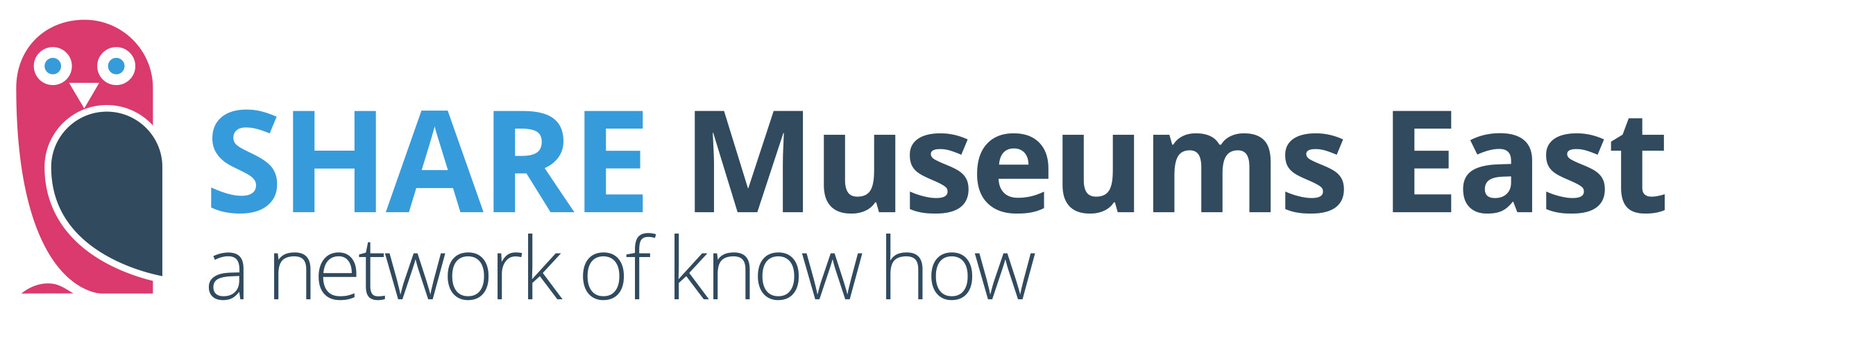

SHARE Emergency Fundraising Scheme
Applications open now 26.03.2020

Introduction
We have created an emergency support scheme for museums in the East of England who are facing financial difficulties as a result of the COVID-19 pandemic. SHARE Museums East will fund and coordinate work that directly supports digital fundraising for museums. Examples of projects that we will fund include:
- Setting up an online donation platform (e.g. JustGiving)
- Creating a social media profile to promote fundraising
- Creating a website or single page that directly supports or links to online fundraising
- Design and creation of electronic newsletter to support fundraising

How to Apply
Museums should contact sharemuseumseast@norfolk.gov.uk with the following information asking to apply to the fund:
- Name of museum
- Outline of proposed project and why the museum needs support (see above for suggestions)
- Two named contacts, email addresses and phone numbers
- Confirmation of approval by Chair of Trustees
- Charity Number (if applicable)
- Confirmation that you will be able to provide a range of information (e.g. museum images, bank account details, and a copy of a photo ID etc.) on request at short notice

Before Applying
Please have a look at these resources when thinking about your project:
Tips for Successful Digital Fundraising
A Guide to Finding the Right Online Donation Platform

We are also offering FREE access to a fundraising consultant. Please contact him to have a chat about your idea before you apply to us: david.burgess@apollofundraising.com.

Eligibility and application criteria
Accredited museums and those officially Working Towards Accreditation from across the East of England are invited to apply.
Exclusions
Applications will not be considered:
• To cover the costs of activities taking place before a grant offer is made.
• By museums that are not Accredited or actively Working Towards Accreditation.
• From National or ACE National Portfolio Museums.

Successful applicants
• Successful applicants will receive confirmation by email or phone.
• SHARE will negotiate with and coordinate the contractor who will develop your project.
• SHARE will pay the approved contractor directly.

Please note: The SHARE is currently working away from the office and with a reduction in hours. We will process applications as quickly as we are able.

For more information and to discuss this opportunity, please contact sharemuseumseast@norfolk.gov.uk

