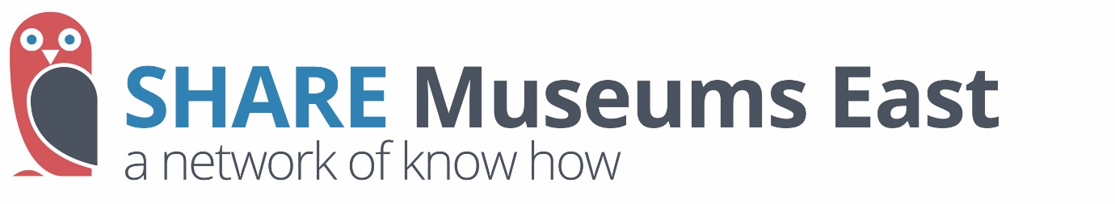
Diversify Your Income - programme outline

Do you want to expand your sources of income?
SHARE is offering 6 museums in the region a two-strand support programme this Autumn. It will provide coaching and training to help you to launch new income streams.

Twelve museums in all from both our region and the East Midlands can participate in an intensive programme which provides hands-on support with income diversification projects. By joining with the East Midlands region we will be able to pair museums up with others of a similar size in some sessions and enable you to network more widely than usual.

- Group Sessions – Three two-hour sessions, starting in September 2021
The first session will launch the programme and its aims.
It will also enable museums to share their specific needs, and the projects which they want to focus on.
Following this, focus for these sessions is likely to include (i) a session on communications and pitching, ahead of (ii) a group reflection session, before presenting progress in income diversification to key stakeholders.
- Monthly Coaching – from October to December 2021.
Each participating museum will participate in two hour-long coaching sessions with an assigned coach. Potentially this coaching may be enhanced by support from peers who have undertaken similar diversification projects.
- Network Building -
between the group sessions, there will be an online group for participant organisations to share challenges and successes and build connections between organisations.
- Training Sessions - All participants will be encouraged to make use of the wider training programme (see below), in order to gain specific understanding in key income areas and extend networks.

Training
All the group is invited to join the training sessions, but these will also be open as general training sessions to other museums. Each session will last for two hours, and will contain key theory, case studies from the heritage sector, opportunities for discussion and interaction, and practical recommendations for implementation:
Topics will include:
- Introduction to Fundraising: will introduce the basics of fundraising, including key income streams and top tips for maximizing success.
- Digital Fundraising Campaigns: will support you to design and launch digital fundraising campaigns through which to enhance individual giving as an income stream.
- Writing Great Applications: will provide practical advice and guidance for developing compelling bids to Trusts & Foundations.
- Online Ticketing: will highlight the opportunity offered by online box office systems, key considerations in choosing a platform, and
how to successfully integrate new systems into day-to-day activity.
- Establishing an E-Commerce Offer: will support organisations new to online retail to launch an e-commerce offer appropriate for the organisation, that diversifies income and engages new audiences.
- Developing On-Site Retail: will highlight best practice in onsite retail areas for earned income with practical tips for launching these offers.
- Income from Hires: will consider how buildings and spaces managed by museums and heritage sites can be successfully hired for commercial or community use.
- Trustees Supporting Income Diversification: will support Trustees to consider their role and responsibilities in supporting income diversification strategies and delivery.

Expressions of interest are invited by 16 July, with the programme to commence in September 2021.
Preference will given to Accredited Museums which are not NPOs, but other museums may be considered.

