Emergency Planning
Template for museums

February 2023

Emergency Plan

Name of museum:
Address:
Phone:
Contact email:
Date of plan:
Date for review: | (Remember: Emergency plans should be reviewed annually or sooner if an incident occurs)
Contents

- Institutional information 5
  - Site and collections information
  - Location of Emergency Plan & salvage response 6
  - Keyholders

- Essential services 7
  - Location of service control points
  - Utilities / essential services 8
  - Site plan 9

- Emergency evacuation procedures 10
  - Use of fire alarm
  - Emergency evacuation procedure

- Emergency response team 11
4.1 Staff and volunteer call-out list
4.2 Roles and responsibilities
4.3 Prepared press statement 13

- Types of emergency
  - Fire 14
  - Gas Leak 14
  - Electrical failure 14
  - Flood 15
  - Medical incident 17
  - Theft and vandalism 18
  - Abusive visitor 18
  - Security and terror attacks 19
  - Pandemic or public health incident 20
  - Insect infestation 21
  - Mould infestation 22

- Salvage
6.1 Preparation 23
6.2 Priority for salvage: Floor Plan and grab list 24

- Suppliers & contacts 28
Appendices

Appendix A Risk assessment template 29

Appendix B Building maintenance checklists 31

Appendix C Incident assessment form 34

Appendix D Salvage recovery sheet 35

Appendix E Salvage notes 36

Appendix F Salvage kit list 43
1. Institutional information

1.1 Site and collections information
Add a short paragraph here outlining the type and size of your museum collection and site.

1.2 Location of emergency plan and salvage response

Location of emergency plan (on-site)
Location of emergency plan (off-site)
Location of salvage kit
Location of salvage areas (on-site)
Location of salvage areas (off-site)

1.3 Keyholders

Keyholder name | Role | Phone number

2. Essential Services

2.1 Location of service control points: (edit as applicable)
Ensure all control points are included, e.g. multiple stop cocks or electric mains panels

Stop-cock (water)
Electricity mains switch
Gas isolation valve
Fire alarm panel
Security alarm panel
Fusebox / Circuit stop
Manhole(s)

NB: If you smell gas, call 0800 111 999 and undertake the following procedures:

- Do not smoke or strike matches

- Do not turn electrical switches on or off

- Do put out naked flames

- Do open windows and doors

- Do keep people away from the affected area

- Do turn the meter off at the control valve unless the meter is in a cellar
2.2 Utilities / Services contact details

Utilities/Services | Company name | Emergency phone number | Non-emergency phone number | Customer reference or policy number
Electricity
Gas |  | 0800 111 999
Water
Insurance
Security
Alarm
CCTV
Phone/internet
Maintenance / building contractor
2.3 Site plan

Insert floor plan of the museum (including all public and non-public areas) here.
- Mark service control points
- Include the location of all break glass fire points, fire extinguishers and fire blankets.
- Colour code the fire extinguishers to show what type it is (water, carbon dioxide, etc).
- Additional copies of this site plan can be produced, laminated and kept with the emergency plan. In the event of an emergency, the Fire Service can use these to identify where fire-fighting equipment is situated. You could also include any risk information that the Fire Service would need to know.

3. Emergency evacuation procedures

3.1 Use of fire alarm
- When the fire alarm sounds, it is in the form of (insert details specific to your fire alarm, e.g., a continuous ringing bell)
- The fire alarm is tested routinely every (insert day) at (insert time)

3. 2 Evacuation procedure
To evacuate the premises in an emergency:
- Raise the alarm by using the Break Glass call points situated around the building.
- Do not take personal risks.
- Do not attempt to rescue any objects whilst leaving the building, either from display or storage areas.
- Make your way to a Fire Exit, closing doors behind you if possible.
- Go to the designated assembly point at (insert outside location).
- An allocated member of staff/volunteer may sweep the building if safe to do so.
- On leaving the building, take a mobile phone with you if possible so that you can call emergency services once you are safely outside the premises.

(Remember: insert any of your own site-specific evacuation procedure information here too)

On hearing the fire alarm:
- Make your way to a Fire Exit, closing doors behind you if possible.
- Do not attempt to rescue any objects whilst leaving the building, either from display or storage areas.
- Do give assistance to others to help them reach safety
- Go to the designated assembly point at (insert outside location(s) of fire assembly point).
- Do not attempt to re-enter the building until you are told it is safe to do so.

In the event of a major incident, you may need to inform neighbouring buildings. Add their contact details here:
4. Emergency response team

4.1 Staff and Volunteer Call-Out List
Think about the distance from home to the museum for staff and volunteers – who will be able to respond the quickest? Will you have an order of priority to call based on seniority, distance from site, etc?

Name | Job title | Work phone | Mobile | Home phone

4.2 Roles and responsibilities of Emergency Response Team
These are some suggested roles in the event of a major emergency. Don’t panic if you usually have only a small team! List the people that may be available to help and appraise them for their skills, abilities and likely aptitude in a stressful situation. If it’s useful to do so, you could assign roles to individuals but remember that your first choices may not be available in the event of an incident so think about deputies too.

These roles are just suggestions - you can combine jobs and change roles around to make them relevant to your museum. The important thing is to make the best use of the people available.

Overall Co-ordinator
- Contacts insurers
- Contacts governing body
- Stays in one place and is available to make decisions
- Undertakes continuous risk assessments
- Acts as, or appoints, media contact
- Supports team
- Maintains a record of events and decisions made

Building Recovery
- Liaison with emergency services, Co-ordinator and Salvage Co-ordinator
- Responsible for security of site and access to it
- Co-ordinates with contractors and any equipment hire

Registrar/Collections Management
- Liaison with lenders
- Object identification
- Documentation
- Allocating destination for salvage, i.e., wet or dry treatment

Administrator
- In charge of resources
- Obtains materials and equipment on advice of others
- Deals with IT recovery and ensures collections databases are accessible for Recovery Team
- Responds to and co-ordinates enquiries

Recovery Co-ordinator
- Advises on conservation matters
- Monitors Health & Safety of recovery teams
- Monitors the human resources situation; organises breaks, identifies people who are not coping

Dry Recovery Team Leader
- Oversees the dry recovery team
- Advises on treatment and packing
- Liaises with Recovery Co-ordinator

Wet Recovery Team Leader
- Oversees the wet recovery team
- Advises on treatment and packing
- Liaises with Recovery Co-ordinator

Salvage Team Members
- Remove objects from display or storage areas, sending them to the relevant treatment areas
- Assists with wet/dry recovery teams as instructed
- Help with refreshments

4.3 Prepared Press Statement

This should be edited to suit your needs but, if you have something prepared in draft, it will ensure you cover the basic need-to-know elements of an emergency and provide reassurance the incident is under control.

Agree the wording of your prepared press statement with your governing body before you include it in your Emergency Plan.

Only to be released on the authority of the Overall Co-ordinator:
‘A fire / serious flood / incident (delete as applicable) occurred in the NAME OF MUSEUM last night / early this morning. The Fire Service attended the scene quickly and have worked hard to extinguish the fire / respond to the incident and limit the damage to our collections and building (edit as applicable).

Our Emergency Plan has been activated and we are now working to salvage our holdings. The building will be closed for the duration and we will circulate further information over the coming days.’

Contact: insert name, role, phone number
5. Types of Emergency

5.1 Fire

In the event of a fire:
- The alarm should sound automatically. If not, raise the alarm by using the Break Glass call points situated around the building.
- Do not attempt to use fire-fighting equipment (e.g., extinguishers), unless you have been specifically trained to do so and you feel confident that you can. Do not take personal risks.
- Do not attempt to rescue any objects whilst leaving the building, either from display or storage areas. Salvage should only commence once the Fire Service give permission to re-enter the building.
- Make your way to a Fire Exit, closing doors behind you if possible. Remember, never allow the fire to come between you and the exit and do not break windows unless you have no other means to escape.
- Offer assistance to anyone who may need help to reach assembly point
- Go to the designated assembly point outside at (insert location).
- Call 999 as soon as it safe to do so.

5.2 Gas Leak
Raise alarm and evacuate building as for fire – see above.
A phone call should be made immediately to the National Gas Emergency helpline on 0800 111 999. You will be advised of further actions by the operator and service engineers upon arrival.

5.3 Electrical Failure
- Evacuate building as for fire but do not sound fire alarm.
Torches are kept (enter location(s) here)
- Manual overrides for lifts and electric doors are found at (enter location(s) here)
Emergency lighting should continue to work but if in total darkness, ask everyone to remain calm whilst one member of staff, who is familiar with the building, proceeds cautiously to a lighted area and raises the alarm by telephoning for assistance.
Ensure a member of staff remains with visitors in the dark area whilst help is summoned.
Be prepared for possible power surge when power is turned back on. Unplug as much as possible.
Report the failure to the utility supplier. You can also dial 105 to report the power cut www.powercut105.com

5.4 Flood
Add a few sentences here about the potential risk of severe flooding. Think about your own flood risk area. Do you need to register for flood warnings? Do you need to store sand and bags or have flood barriers in place? Also, how likely is it that the flood waters will reach a height as to cause damage to objects? Do you need a plan to move objects to a higher level in the event of a flood?

In the event of a major incident:
- STOP and THINK! Is there a risk of electrocution? If you need to switch off your electricity supply and there is water present, get a qualified person to do it. If unsure, contact power company or electrician. Do not touch sources of electricity when standing in water.
- The person in charge must assess the situation before you start salvage work and undertake appropriate risk assessments before anyone enters the flooded area. Avoid entering contaminated water, speak to a professional if unsure.
- Assess the severity of the flood:
  - How deep is the water?
  - Is the water level still rising? If so, how fast?
- On discovering a water leak or flood, speak to (insert name of person responsible for building maintenance), who will isolate water mains or stop the ingress of water. OR, if you are able, isolate water mains yourself and inform (insert name) as soon as possible.
- For large amounts of standing water, contact the Fire Service or emergency plumber to pump it out. Salvage may not be able to start until the area is deemed safe. If this is the case, use the time to prepare salvage treatment areas.
- Form a human-chain (if enough people are available) to move crates and objects. This saves time and prevents congestion in tight areas.

Flood water – Health and Safety

Flood water can contain sewage, chemicals and animal waste:
- Wear waterproof outerwear, including gloves and wellington boots.
- A face mask and goggles are advised.
- If mould is present then the face mask must be of a grade that filters mould spores.
- Do not let flood water come into contact with open wounds or grazes. If it does, obtain an anti-tetanus injection as soon as possible if you don’t have an up to date one or are unsure.
- Always scrub and disinfect hands before eating.
- Do not work in deep or fast flowing water.
- Be aware of concealed hazards such as blown manhole covers, broken glass or slippery silt underfoot.
- Be aware of the effects of cold water over time, e.g., reduced dexterity and mobility; regular breaks may be needed.

Water leak (from above):

If water is dripping onto display cases or stored collections assess the severity of the leak and either:
- Cover the case with a large sheet of polythene and ensure that the water does not pool near the base of the case.
OR
- Remove the object(s) from the case but make sure you have all the equipment needed to hand before opening the case.

Think! Are some objects more at risk than others? (i.e., on a lower shelf or nearer the source of the water ingress). Are any of the objects at risk on the Priority for salvage floor plan (see page 24)?
5.5 Medical incident

Summon help. The onsite first aider should be contacted immediately.
If possible, do not leave the person alone, reassure them and clear the area.
If appropriate, or unsure of what to do, dial 999 – they will advise.
As soon as possible, contact a friend or relative of the person involved.

Staff and/or volunteers trained in first aid:
Name | Job title / role | Work phone | Mobile | Level of first aid training | Training renewal due date

Location of First Aid Kits
First aid kits are situated in the following areas of the museum:
- (insert room name/number here)
- (repeat as required)

5.6 Theft and vandalism

If theft or vandalism is occurring dial 999

If you suspect an object has been stolen:
- Report the loss to the person in charge of security at your museum; they should then report this to the head of the museum.
- The head of the museum should contact all staff/volunteers to ensure that the object has not been removed from its usual position for another reason, such as conservation treatment, for example.

Responding to an incidence of theft or vandalism:
- The head of the museum must call the local police (insert telephone number here) to report the incident.
- Do not move anything from the area until the police have been to the museum.
- Provide any photographs of a stolen object to aid identification as well as dimensions and any other relevant information.
- Provide the police with CCTV footage, if possible.
- Telephone your insurers to inform them of the incident.

Insurance company: (Insert details here)
Policy number: (Insert details here)
Telephone number: (Insert details here)

- If a stolen object is on loan to your museum or does not belong to the museum, contact the lenders to inform them of the situation.
- If the museum has been damaged by the theft or act of vandalism, make sure the building is secure until proper repairs can be undertaken.
- If an object has been damaged by the vandal(s), contact a conservator for specialist advice.

5.7 Nuisance or abusive visitor (e.g., violence, threats, abusive language, drunkenness)

- Alert a colleague as quickly and quietly as possible.
Keep calm and try to diffuse the situation as best you can. Do not put yourself or others at risk.
If the visitor does not amend their behaviour, they should be asked to leave. If the situation continues the police should be informed by dialling 999.
Await arrival of police for physical removal of the person. Do not engage in physical contact.

5.8 Security threat or terror attack

Security threats could include the following:
- A threatening call directly to the building
- A threatening call received elsewhere and notified to you by the police
- The discovery of a suspicious item in the building or a vehicle outside
- The discovery of a suspicious item elsewhere notified to you by neighbours or the police

The decision to evacuate your building will usually be undertaken by the person in charge of the museum, but the police will also advise you.

The evacuation procedures for this situation will differ to those required for a fire:
- Your assembly point needs to be much further away than that for a fire, at least 500 metres from the building. Car parks should not be used.
- Your evacuation route will have to be flexible, depending on where the threat is.

Bomb threat (telephone call)
Keep calm and listen carefully. Try to keep the caller talking to learn more information and note down details, if possible.
Alert a colleague to call 999 whilst you keep the person on the phone. If you cannot do this call 999 yourself as soon as the caller hangs up.

Suspect package
Do not touch the bag or package. Clear the area and restrict access.
Check with all staff and visitors to see if they have left any item unattended.
The person responsible for the museum should contact the police and take advice as appropriate.
If evacuation is recommended, sound the fire alarm and evacuate the building.

Act of terrorism (e.g., explosion or armed individuals)
Run, hide, tell
If the incident occurs within the building, find the safest exit as quickly as possible.
If there is an explosion outside the building, stay inside. Keep away from windows and external doors in case there are secondary devices.
In the event of armed individual(s), find somewhere to hide. Barricade yourself in if possible. Remain quiet and set mobile phone to silent mode. Message someone to raise the alarm and call 999 when it is safe to do so.
If there is a fire, stay low to the floor and exit as quickly as possible. Cover your nose and mouth with a wet cloth if you can. If a door is hot to the touch, don’t open it.
Alert the police as soon as possible.

5.9 Pandemic or Public Health incident
Include here your plans for closure in the event of a national lockdown. Will staff be allowed on-site to check security? Does there need to be maintenance of environmental controls or heating? How would a lockdown effect business continuity?

- If staff remain on the museum premises, they should follow government guidelines.

- Good hygiene practices must be followed at all times:
  - Staff should not come in to work if they are feeling unwell
  - Hands must be washed regularly with soap and water for at least 20 seconds
  - Coughs and sneezes must be covered with a tissue that is then disposed of
  - Frequently touched surfaces must be regularly cleaned

- Whilst staff may be permitted to work remotely where this is possible, objects from the museum collection must remain on-site at the museum for security and conservation purposes.

- When working from home, staff must ensure they maintain regular contact with their employers and colleagues. Managers will also maintain contact with staff unable to work.

- Staff are under no obligation to continue to work remotely if they become ill.

- In the event of a pandemic, large scale events must be cancelled or postponed.

5.10 Insect infestation
On discovering a suspected or actual insect infestation in your collections, immediately isolate the affected object(s) from the rest of the collection. This will prevent any potential infestation from spreading and allow you to monitor the object for signs of infestation.

To isolate objects:
Smaller objects:
- Place individual objects inside a polyethylene bag, squeeze out as much air as possible and seal up the opening of the bag with parcel tape.
- Label the bag with the object details (name and object number), the date of when it was placed in the bag and a sign stating, ‘Do not open - monitoring for insect infestation.

Larger objects (too large to be placed in a bag):
- Place each object on a large sheet of polyethylene and wrap the object, so that it is completely enclosed, and seal with parcel tape. Ensure that the edges of the polyethylene are folded over several times before they are securely taped. Try to remove as much air as possible before sealing.
- Label the package with the object details (name and object number), the date of when it was placed in the package and a sign stating, ‘Do not open - monitoring for insect infestation’.

Monitor the object. If there are signs of an active infestation contact a conservator or your Museum Development Officer, who will be able to advise you further.

If the object is on loan to your institution or does not belong to your museum, you must contact the lender or owner before any further treatment is undertaken.

5.11 Mould infestation
It is not possible to identify a mould and whether it is harmful without laboratory testing, so it is safer to treat all mould as if it were harmful. The effects of breathing in mould spores are cumulative and can lead to health problems in later life. Always take precautions when mould is present. On discovering a mould infestation, isolate the affected object(s) from the rest of the collection. If the object is on loan or does not belong to your museum, contact the lender or owner before any further treatment is undertaken.

Checking for mould:
- Wear nitrile / latex gloves when handling objects.
- Wear a face-mask suitable for use with mould spores and particulates.
- Check if the material feels damp and/or there is a mouldy smell.
- In the early stages of growth mould often appears as a fine web of filaments (hyphae) that can be easily confused with dust, dirt and cobwebs.
- In later stages, mould generally develops a bushy appearance and fruiting bodies, containing spores, can be seen under magnification.

Testing for mould:
- Brush the mould with a fine, natural hair, brush (not synthetic) to see if the mould is dormant (dry and powdery) or active (soft and smeary). As a general rule, active mould will continue to grow and damage collections.
- Dormant mould will cause no further damage unless relative humidity increases to 70-75% or more when spores are likely to germinate and the mould becomes active.
- Foxing on paper can be confused with mould. It appears as red-brown stains in discrete spots or irregular splotches, usually with no visible hyphae or mould structure.

Stopping mould growth:
- Reduce humidity: Mould can form at 65% relative humidity (RH) if there is poor ventilation.
- Do not turn up the heat. This will make it grow faster.
- Use cold air fans to increase ventilation
- Do not use bleach or domestic products

To isolate objects:
- Wear nitrile / latex gloves and a face-mask suitable for mould spores.
- Place individual objects inside a polyethylene bag. For larger objects, place on a sheet of polyethylene and wrap the object so it is completely enclosed (ensure the edges of the polyethylene are folded over several times before securely sealing with parcel tape). Try to remove as much air as possible.
- Label the bag with the object details (name and object number), the date of when it was placed in the bag and a sign saying ‘Do not open - mould infestation’.
- Place somewhere cool. The object should not remain in the bag for a long time as this will encourage further mould growth. Contact a conservator or your Museum Development Officer as soon as possible.
6. Salvage

6.1 Treatment areas for assessing salvaged collections:
- (insert location)
- (insert location)
- (insert location)

Also consider any local authority, other museums, or neighbouring buildings that you may be able to arrange to use in the event of a major emergency where you need to move collections off site. However, remember to think about insurance cover when moving objects off site.

See Appendices D, E and F (pages 34-43) for more information about undertaking salvage and treatment of specific materials.

If in doubt, contact a conservator who will advise.

6.2 Priority for salvage: Floor plan and grab list

Floor plans:
Floor plans showing where priority objects are located should be inserted here. They do not need to be computer generated; simple hand drawn ones can do the same job. Bear in mind that it may be a member of the emergency services removing objects for salvage so the information needs to be as clear as possible. Copies of the floor plans can be laminated for use in an emergency.

Include:
- Key features of the building, with entrances clearly indicated
- Room name or number, and key numbers if relevant
- An image of the priority object(s)
- Simple name of the object - avoid using technical terms. Object dimensions can also make identification easier.
- If necessary, make a note of how the object is displayed (e.g., screwed to a wall with Philips screws) and what equipment is needed to remove it. For heavy or large objects note if it requires more than one person to lift it.

Grab lists:
If your priority list of items is fairly small, you may be able to include all of the above information on a single floor plan but it can also be helpful to have a more detailed ‘grab list’ to accompany the floor plan. You could include your grab list within your Emergency Plan but it is helpful to have a copy of just the grab list and priority floor plan stored separately so you can hand it straight over to the Emergency Services. In the event of a major incident, you may not be able to enter your museum site.

Guidance notes: Choosing priority objects for salvage
Which objects / collections are most important to the museum? This can be based on several factors such as:
- The rarity of an object
- Its value (though this should not be the sole consideration)
- An important historical link to the museum
- Its vulnerability to fire, flood, etc

You may find the Collections Trust resources on reviewing significance helpful in identifying priority objects. https://collectionstrust.org.uk/resource/reviewing-significance-3-0/

Some objects that you want to put on a priority salvage list may not be moved easily and require specialist lifting equipment that you do not have. In these cases, you should think about what can be done to reduce the risk of damage. For example:
- Move objects away from possible hazard and / or closer to exit
- Change method of display or storage to aid removal
- Store protective materials close to object, e.g., polythene sheeting cut to size, polythene covered wooden blocks
- Record object thoroughly in case of loss
Example priority floor plan: (replace with own plan)

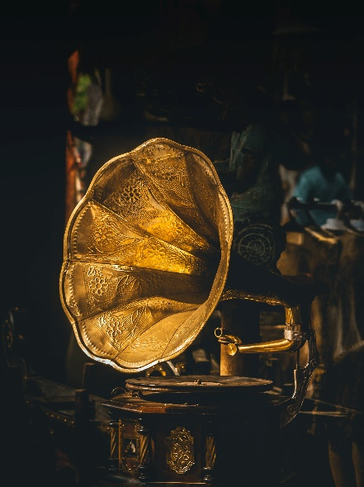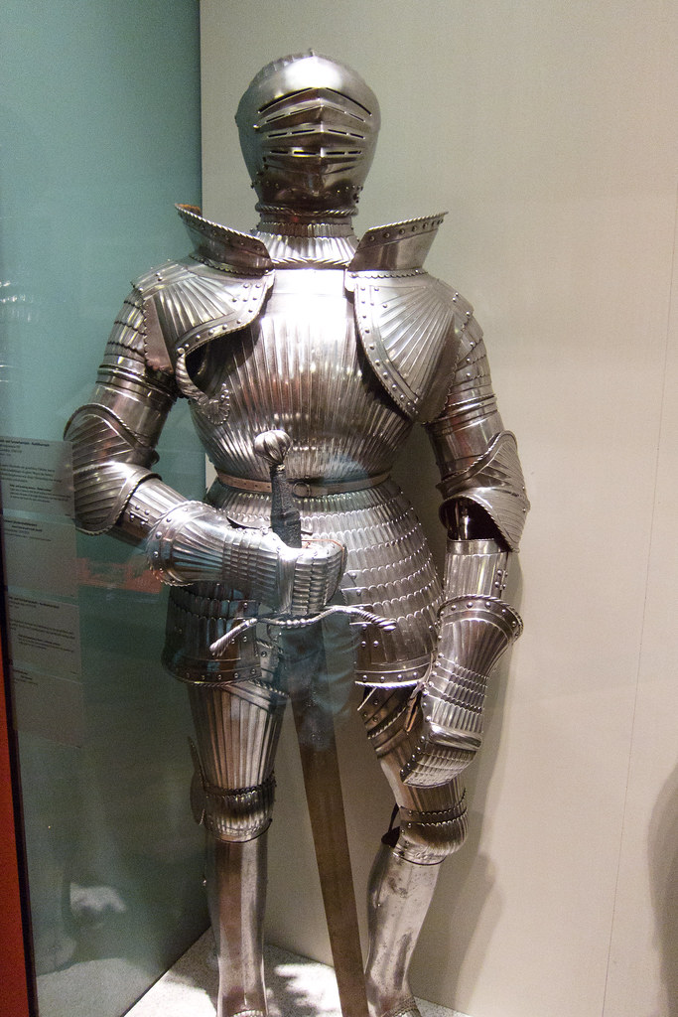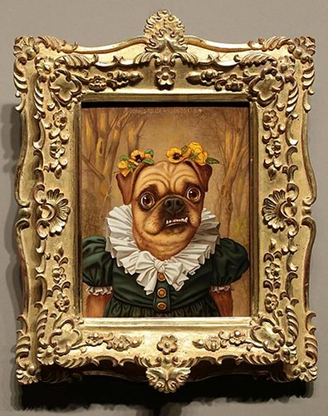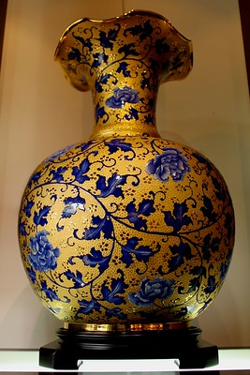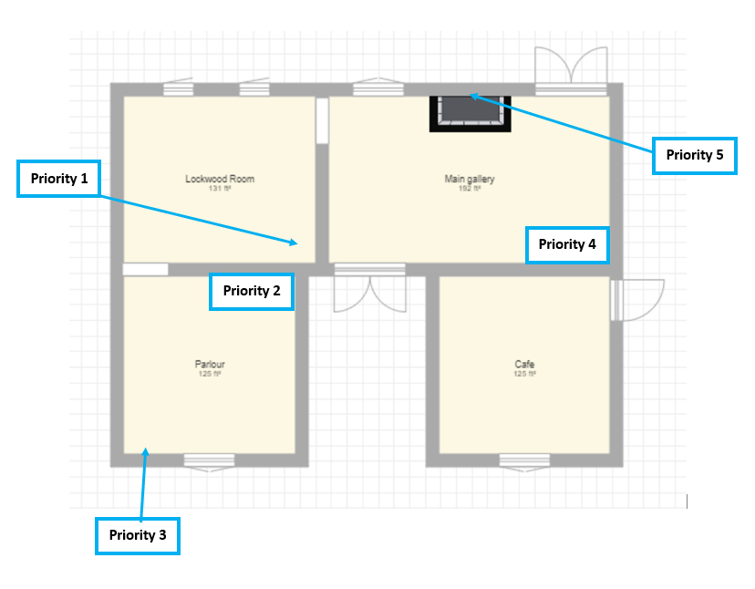
Oil on canvas of dog, gilt wood frame
85cm (h) x 70cm (w) x 12cm (d)

Ceramic vase with gilt
40cm (h) x 25cm (d)

Gold torc
2cm (h) x 8cm (d)

Gramophone
70cm (h) x 55cm (w) x 60cm (d)

Suit of armour
190cm (h) x 80cm (w) x 45cm (d)

Example priority grab list page 1:

Object number: | DCMSM:1964:27
Object name: | Vase
Object Description: | Ceramic vase with gilt and blue enamel
Dimensions: | 40cm (height) x 25cm (diameter)
Image:
Location: | Lockwood Room / display case 4
Keys required?: | Yes – display case 4
Notes for removal: | Handle with care, ideally place into padded box for removal
People required:
Equipment required: | If possible: trolley, box, conservation grade padding, nitrile gloves

Example priority grab list page 2:

Object number: | DCMSM:1959:41
Object name: | Suit of armour
Object Description: | Full body armour, made of steel plates, cotton cloth and leather
Dimensions: | 190cm (height) x 80cm (width) x 45cm (depth)
Image:
Location: | Parlour / display case 1
Keys required?: | No
Notes for removal: | Handle with care, supporting moveable joints. Remove sword separately – hold by handle and support scabbard. Do not remove from scabbard (sword cover).
People required:
Equipment required: | Phillips screwdriver to remove mount fixings
7. Suppliers & Contacts
Insert name, address and telephone numbers of the following types of companies. These are only suggestions – insert any information that is relevant to your museum.

Building Maintenance / Repairs
- Builders and Builders Merchants
- Plumbers
- Electricians
- Drain cleaning
- Locksmith
- Portable Appliance Testing (PAT)

Conservation and Salvage Supplies
- Drying equipment
- Freeze-drying companies
- Conservation equipment
- Crate Hire
- Dehumidifier suppliers
- Pump hire
- Demolition companies
- Fans
- Industrial cleaning
- PPE supplier
- Skip hire
- Tool hire / 24-hour plant hire
- Removal company

Conservators
- For specific materials relevant to your collections
- Local and specialists further afield

Essential Services
- Electricity company
- Gas company
- Water company
- Telephone company
- Security company / intruder alarms

Insurance Company

Temporary Accommodation / Storage
- Local schools, town or village halls, sports centres
- Marquee hire
- Commercial estate / letting agents
Appendix A: Risk Assessment
Emergency planning should aim to prevent emergencies occurring and when they do occur should reduce, control or mitigate the effects. Completing an initial risk assessment will highlight what you can do to reduce the likelihood of an incident occurring and inform the priorities for the emergency plan. Risk assessments and the emergency plan both need to be regularly reviewed and updated.

Undertaking a Risk Assessment
- Review history of incidents / emergencies in the museum or locality.
- Identify all risks to the museum site, building and collection. For example, flooding from river or sea, leaks from roof valleys, fire from faults in old wiring, infestation from food sources.
- Also identify the people who are at risk (e.g., visitors, employees, volunteers, contractors) and any particularly vulnerable groups, e.g., elderly, people with health issues, pregnant women etc
- Rate risks according to probability and impact. The higher the probability of something happening and the greater the impact, then the more urgent it is to deal with the risk (see table below).
- Prepare an action plan to remove or reduce risks. Deal with risks that need little time or money, and plan when and how to deal with those that need more resources.
- Use this information to inform your emergency plan.

Assess the level of risk:
Multiply the Probability to cause harm by the worst possible level of Severity to get a Risk rating (P x S = R). Action will be required for results of 8 or higher. Any activity which scores a multiplied rating above 16 is unacceptable and MUST STOP immediately until improvements have been made.

PROBABILITY | SEVERITY
- Very unlikely  - Unlikely  - Possible  - Likely  - Very likely | - Trivial  - Minor  - Moderate  - Severe  - Devastating consequences

Template Risk Assessment
Incident and cause (if known) | Damage | Risk | Risk Rating Probability x Severity = Risk rating |  |  | Action
 |  |  | P | S | R
Example:  Water leak in storeroom 2 due to blocked gutter causing overflow | Cardboard boxes on top shelf rack A, contents undamaged | Risk of damage to box contents. Risk of mould growth. | 3 | 3 | 9 | Gutters unblocked. Annual maintenance programme put in place – gutters to be cleared every autumn. Objects re-boxed. Priority object moved to less vulnerable position. Polythene to protect top shelves.

Site name and location:
Assessed by:
Assessment date and time:
Review time:
Risk assessment checked by:
Appendix B: Building maintenance checklist

External building checklist (edit as applicable)

 | Frequency | Checked by | Problem found? | Action taken | Check date | Next check due
Guttering / downpipes for leaks, blockages & evidence of overflow
Surface water drains for blockages / obstructions
Rising main / hydrant servicing & check
Rubbish disposal, check of site & procedures
Internal building checklist (edit as applicable)

 | Frequency | Checked by | Problem found? | Action taken | Check date | Next check due
Water pipe systems for leaks / inadequate lagging
Function & accessibility of stop valves (all systems)
Function & accessibility of all down drain points
Cellars / basements / roof spaces for evidence of water penetration
Function of internal drains / sewers for blockages / obstructions
Function & accessibility of circuit breakers
Test of electrical circuits
 | Frequency | Checked by? | Problem found? | Action taken | Check date | Next check due
Maintenance/check air-conditioning plant (including check of duct fire-shutters)
Fire alarm/emergency lighting servicing & check
Fire-fighting equipment (including sprinklers) servicing & check
Security systems (intruder alarms/CCTV) servicing & check
Electrical appliances servicing & check
Gas appliances servicing & check

Appendix C: Incident Assessment Form

What is the nature of the damage?
e.g., fire, smoke, water, sewage, vandalism, other
When did the incident happen?
Include date, time
Which areas are affected?
Has the whole building/site been checked?
Is there power / water / heat?
Look out for standing water
What are possible health and safety issues?
Undertake a Risk Assessment before entering / commencing salvage
Has it been necessary to call in the emergency services?
Are they still in attendance?
What are the environmental conditions?
e.g., damp, sewage, air pollution
What types of object(s) are affected?
Does this include priority items?
How much material is affected?
Quantify if possible
How extensively has water penetrated any display cases, cabinets or storage boxes?
Is the Salvage Kit accessible?

Do we need any external support?
Are any areas of the building in a condition to open?

Appendix D: Salvage recovery sheet
Salvage location  (Room name or number): | Object name: | Object number: | Brief description: | Priority object? | Object on loan? | Treatment location  (wet OR dry): | Treatment required: | Moved to (current location):

Appendix E: Salvage notes

Preparing treatment areas for assessing salvaged collections:
- Prepare treatment areas before any objects are moved.
- Place salvaged objects onto the floor, or tables, padded with blankets or foam covered in tissue. If objects are damp or wet, cover padding with polythene.
- IMPORTANT: dry objects must be kept away from damp or wet objects. Ideally there should be two separate treatment areas: dry and damp/wet.
- Assess the objects that are most at risk or badly damaged. Take into consideration any that are on the priority for salvage floor plan (see page 24).

Documentation during salvage:
- Keeping track of objects as they move is very important.
- Use the Recovery Sheet (Appendix D, page 34) to record basic information about each object.
- Labelling objects will help identify them.
- Digital photos can be taken to aid identification.
- Keep any detached labels with the objects (if possible). Paper or Tyvek labels can be tied to objects whilst they are in the treatment areas.

To salvage objects, you might need:
- Security screwdrivers / display case keys. Cases should remain closed until you are ready to remove the objects.
- Latex / nitrile gloves
- Scalpel or small scissors to remove objects that are tied onto mounts. Some objects may not need to be removed from mounts and can be moved as they are.
- Storage boxes / crates for moving smaller objects. If there are not enough, objects can be unpacked at the treatment area and the boxes re-used.
- Trolleys for moving boxes and crates.
- Waterproof or sturdy footwear

Air-drying:
- Can be undertaken with objects laid out over an area.
- Bread crates (stackable) can be used to lay objects in, as they allow air to circulate.
- A wind-tunnel can be created to aid drying but is not for use with objects that require slow air-drying. To create a wind-tunnel, polythene sheets can be draped over tables and the objects laid out beneath the table. A fan can be placed underneath the table at one end but the air must not directly blow onto any objects. Objects that require quicker drying can be placed nearer the fan.

Dehumidifiers:
- Can be used to help dry out rooms that have been damaged by flooding or are water damaged after a fire.
- If used, the doors and windows of that room must be closed.
- The dehumidifier(s) must be plumbed in or emptied regularly but they must not collect the water in open containers as the moisture will just be recycled back into the room.
- Monitor the rate of drying as drying too quickly can cause damage.

Smoke damage:
- Ensure that a conservator removes any soot as soon as possible as it is acidic.
- Loose soot: remove carefully with a conservation vacuum used at a low suction power and fitted with gauze on the nozzle. Do not use a normal domestic vacuum cleaner.
- Ingrained soot: attempt to use a soot sponge (under the supervision of a conservator).
- If the object is wet: rinse with clear water.
- If objects are dry: send to the dry object treatment area.
- A conservator should advise on further treatments.

IMPORTANT: Wet / damp organic materials (e.g., wood, leather, paper, textile) are at risk from mould growth. Objects should be air-dried within 48 hours to prevent mould growth. If there is a large volume of materials that cannot be dried within this time, undertake freezing (although this is not suitable for all materials). DO NOT ADD HEAT DUE TO INCREASED RISK OF MOULD GROWTH.

Salvage: Treatment of different materials

Basket (vegetable fibres)
- Rinse with clear water, if dirty.
- Drain and blot to remove excess water.
- Stuff with clean, undyed paper towels or cotton sheeting to retain the shape and to absorb stains.
- Cover with clean paper towels. Air dry slowly.
- Change blotting material regularly.

Bone, shell and ivory
- Ivory: do not wash.
- Bone and shell: Rinse with clear water, if dirty.
- Drain and blot to remove excess water.
- Place on blotting paper to air dry Change blotting material regularly.

Books
Most require the services of a conservator, but first aid in situ may be needed.

During an emergency, salvage books from shelving in the following order:
- Take books from the bottom shelf first, but if the shelves are unstable, then work from the top shelf down.
- Pack in separate categories of dry, damp and wet (dry books need to be prevented from becoming damp or wet).
Books should be treated in the following order:
- weak and wet books
- weak and damp books
- strong and wet books
- strong and damp books

Wet books:
- Rinse wet books if dirty, but keep the book closed.
- Clean gently with undyed cotton cloths or paper towels before opening the book, then allow it to air dry in cool air (never force-dry a wet or damp book using heat).
- If possible, air dry; stand up books that are strong enough on one end with pages fanned out to provide air circulation.
- For other books, interleave every few inches with blotting paper, change when wet.
- Do not try to force apart the pages of a drying book. They will separate as they dry out.
- Do not try to shut books that are found open.
- Very wet: wrap in freezer paper or waxed paper (not in acid free tissue paper), pack in crates spine down and freeze.
- Shiny 'art' paper (e.g., type used for printing illustrations) is heavily 'loaded' with china clay, and if left to dry the pages will settle into a solid mass. Try to separate sheets of art paper from each other and from text paper as they dry, using polyethylene sheets or silicone release paper as interleaving.
- Create a drying tunnel if there are large amounts of books that need drying (see separate section on air-drying). If used, ensure that electric fans blow cold and do not ruffle or disturb the pages.
- During drying, check books for signs of mould growth. If they cannot be dried within 48 hours, a conservator will need to arrange freeze drying.

Ceramics and glass
- More susceptible to damage from heat than from water.
- Identify the ceramic type and consult a conservator on drying procedures.
- If broken, cracked, has mineral deposits or old repairs the ceramic should be placed in a clean, transparent polythene bag until it can be treated. Seal the bag and monitor for mould.
- Never wet unglazed ceramics, damaged glazed earthenware or soft paste, repaired or restored areas, gilded decoration or painted glass or early (pre-1700) glass.

Clocks and watches
- The metal movements of clocks and watches will be very badly damaged if they get wet.
- Quick treatment is essential. If objects are very wet, only carry out gentle blotting where accessible. Do not attempt to clean.
- Contact horological conservator as soon as possible for further advice.

Furniture
- Care must be taken when moving furniture as glues on joints and veneers will loosen and gesso can dissolve.
- Blot dry all accessible areas (do not rub or wipe), changing the blotting material regularly. Do not freeze wet furniture.
- Areas of marquetry, lacquer and painted surfaces are particularly fragile.
- Do not blot gilded areas, as these surfaces are extremely fragile.
- Remove drawers, open doors and let the furniture air dry slowly.
- Use an electric fan (set to cool) to improve the ventilation during the drying process, but do not allow the air to blow directly on any objects.
- If larger pieces of furniture cannot be moved, cover them with polyethylene sheeting, removing the sheeting when there is no longer a risk from water damage.
- If floors are wet, stand the furniture on blocks of wood wrapped in polyethylene, which will prevent the water from travelling through the wooden blocks into the furniture.

Leather
- Rinse / sponge with clear water to remove mud (if present).
- Drain and blot to remove excess water.
- Pad with towelling or newsprint (unprinted) to maintain the shape of an object.
- Air dry. Manipulate tanned fur skins during drying to keep them flexible.

Metals
- Moisture can seriously damage metals.
- Wear latex / nitrile gloves when handling.
- Salvage areas should be warm and dry, in contrast to conditions required for other objects. Do not freeze.
- If suitable, rinse / sponge and blot the metal object. Pay particular attention to decorative areas.
- If an object has an applied finish (e.g., gilding or paint), do not clean.
- Air dry objects as quickly as possible (e.g., with an air tunnel), unless the object has an organic component (ie a material of animal or plant origin, such as leather or cotton), then dry slowly.
- Keep flaking surfaces horizontal.

Natural History (shells, fossils, insects, birds’ eggs, skins and stuffed animals)
- Swab off any excess water with kitchen roll (do not use blue paper towels).
- Fur and feathers should only be wiped in the direction of the hair or feathers.
- Damp: Leave in a cool dry room with good ventilation (use electric fans to improve ventilation but do not allow the air to blow directly onto the specimens).
- Wet: If skins and furs have become soaked, place in a polythene bag and freeze them (they can be freeze-dried at a later date).
- Skins can crack open and burst when drying out.
- Some items may not be very well cured and moisture could cause decomposition and further complications. Seek advice from a conservator immediately.
Paintings (general)
- Paintings and their frames are delicate and should be handled with care (lift pictures by their frames and not their stretchers).
- Unglazed works are at risk from scratching and abrasion. Keep away from sharp objects (e.g., belt buckles and jewellery) and do not place pressure on the canvas.
- If moulding detaches from a frame, place in a sealable polythene bag and label it (note which frame it came from).
- Large paintings, however important, may have a lower priority for salvage because of the difficulty in moving them.
- Protecting in situ: Use polythene sheeting to protect paintings from smoke and water damage when it is impractical to remove them.
- Glazed works: many of the works will be very heavy. Use two people to move them (very large works require more people).

Paintings on canvas
Wet:
- Require urgent attention as there is a risk of flaking. Contact a conservator.
- Handle gilded frames with care as surface is easily removed when touched.
- Carry the painted surface away from the body to minimise the risk of clothes rubbing against the painting’s surface.
- Remove the canvases from frames in a safe, dry place. Do not separate canvases from their stretchers (wooden bars).
- Place paintings on blocks to lift them off the surface (this allows air to circulate). Keep paintings horizontal and paint-side up with nothing touching the surface. Avoid direct sunlight.
- Do not stack wet paintings or frames against each other.
- Wet paintings may turn white. This can be reversed by a paintings conservator if the damage is mainly to the varnish layers.

Dry:
- Torn or scratched paintings can be treated later.
- Place framed and glazed paintings in a sturdy crate and put padding between items before they are moved (e.g., rolls of bubble wrap covered with acid-free tissue).
- Can be stacked vertically, with no more than four similarly-sized paintings in each stack. Stack front-to-front, back-to-back. Never lean a frame against the canvas of another painting.
- Do not rest directly on the floor; use foam blocks or similar.

Paper / prints (see also separate section for books)
Paper is very susceptible to damage and should be considered a priority item for attention.
- Handle with care, as wet paper can be weaker and heavier.
- Do not attempt to pick pieces of wet paper up unsupported; use Melinex sheets for sliding under paper items floating in water. The paper will stick to the Melinex, which then acts as a support.
- Lay out separately on blotting paper (do not stack as they may stick to each other). Change blotting paper every 2-3 hours.
- Do not attempt to separate or unfold sheets that are stuck together.
- Air dry using a good cool air circulation, do not add heat.
- Monitor for mould growth (see separate section on preventing mould).
- If air-drying is not possible, freeze or pack in polythene bag and store in cool dark place. Contact a conservator immediately.

Photographs
- The emulsion of a photograph will become sticky when wet and may stick to other objects.
- Mould grows very quickly on photographs, particularly if gelatine is present. Inform a conservator immediately if mould growth occurs.
- If wet and contaminated with dirt, rinse in a bowl of clean, cold water; do not rub or wipe the surface.
- If wet, separate from each other carefully, spread out and air dry as quickly as possible. Lay flat, image side up, on blotting paper. Do not freeze.
- Do not dry with a hairdryer or other heat source.

Plastics
- Fire / heat: thermal stress can cause physical damage to a plastic material.
- Contact a conservator for advice.

Stone, sculpture and plasterwork
- Marble, stone, scagliola and plaster are porous and will absorb water and dirt. Alabaster will dissolve in water. Do not attempt to remove soot or smoke damage.
- Damp / wet stone: do not freeze.
- Use trolleys to move heavy, smaller pieces
- Smooth-surfaced stone should be blotted gently, but not if there is an applied surface (e.g., paint).
- Rough-surfaced stone or stone with a surface finish: do not blot dry. Put on a plastic sheet or in a bread crate (air can circulate).
- Check for efflorescence of salts (salts appearing on the surface as the stone dries). Contact conservator if this occurs.
- Sculpture may be too heavy to remove. Cover in situ with polythene to protect from water damage.
- Wooden blocks covered in polythene can be placed under objects that cannot be moved, to raise them off the ground and prevent the absorption of water.

Textiles
- Damp / wet textiles can be easily torn and dyes can run to other areas. Handle with care: textiles are heavier and weaker when wet.
- Do not unfold delicate fabrics.
- Do not stack; allow for a large area to lay out textiles when drying.
- Drain and blot with clean towels, kitchen roll etc to remove excess water (never wring out a textile).
- Shape and pad out items to their original forms using nylon netting as padding.
- If possible, isolate metal fixings by using acid-free tissue to prevent corrosion.
- Air dry objects or freeze (but do not freeze if object is of composite materials e.g., with wood, metal etc without further advice).

Wood
- Remove excess moisture from surface by blotting gently using kitchen roll.
- Air dry slowly to prevent warping and shrinkage.
- Check painted surfaces for blistering or flaking. Contact a conservator if this is a problem.

Appendix F: Salvage Kit List
A salvage kit is a selection of equipment and materials that are securely stored for use in an emergency. It should be easily accessible 24 hours a day. The contents should reflect the greatest risks identified by your risk assessment. Contents can be built up over time. Some contents will have a shelf life and need replacing periodically.

The following lists are suggestions - you will need to prioritise and think about any other site-specific items that you may need.

Container for kit
Needs to be easily movable; may need more than one crate to reduce weight.
Wheelie bins, wheeled plastic crates and toolboxes have been used with success. It could also contain a separate first aid kit.

Wet recovery materials
Mop
Bucket (square ones are better for scooping up water)
Dustpan
Brush
Absorbent materials (e.g., squeegees, booms, plain newsprint, no-dye paper towels, kitchen roll, blotting paper)
Plastic trays and crates

Recording materials
Salvage recovery sheet
Clipboard
Pencils
Waterproof pens
Notebook
Waterproof (Tyvek) labels
Paper labels
String
Scissors
Bulldog clips
Cotton tape

Tools and equipment
Torch (windup or with spare batteries)
Head torch
Extension lead
Screwdrivers
Stanley knife
Parcel tape
Claw hammer
Pliers
Crowbar
Holepunch
Webbing tape
Carrying straps

Materials
Polythene sheeting
Bubblewrap
Acid free tissue
Plastazote
Dust sheets
Fire blankets
Freezer bags
Bin bags
Masking tape

Protective clothing
Waterproof coveralls
Gloves (variety)
Goggles
Masks
Wellington boots
Hard Hats
Hi viz waistcoats with i.d.

Person responsible for upkeep of kit: (name)
Date last checked:
Date next due: (1 year from above date)

"Replica of Antique Vase" by Prayitno / Thank you for (12 millions +) view is licensed under CC BY 2.0. "Suit of Armour" by quinet is licensed under CC BY 2.0. "Fwd: ROLLER GREETING" by Wonderlane is licensed under CC BY 2.0. "Torc Torque The celtic crown jewels" by dad1_ is licensed under CC BY 2.0.

